|  |  |  |
| --- | --- | --- |
|  | Integration Test Results | |
| 8/22/2013 | Graduate Capstone |  |

Table of Contents

1 Introduction 17

1.1 Intended Audience 17

1.2 References 17

1.3 Revision History 17

2 Coding Standards 18

# 1 Introduction

@TODO: Explain the introductions

## 1.1 Intended Audience

@TODO

## 1.2 References

* <http://www.dir.texas.gov/SiteCollectionDocuments/IT%20Leadership/Framework/Framework%20Extensions/SDLC/SDLC_testPlan_instructions.pdf>
* <http://www.engr.sjsu.edu/gaojerry/course/287/TestPlan.doc>
* <http://www.jiludwig.com/templates/ATTemplate.doc>
* <http://www.moct.gov.sy/ICTSandards/en_pdf/31.pdf>
  + Ok source
* <http://ltodi.est.ips.pt/es/index_files/pdf/TestPlanOutline.doc>
* <http://www.smithmusic123.com/application/views/download/download_file/Testing.pdf>
* <http://sucs.org/~tobeon/testing.pdf>

## 1.3 Revision History

|  |  |  |  |
| --- | --- | --- | --- |
| Name | Date | Reason For Change | Version |
| Andy Bottom | 08/16/2013 | Added Integration Test Ret | 0.1 |

# 2 @TODO

# 3 Results

@TODO

## 3.1 INT-01

|  |  |  |  |
| --- | --- | --- | --- |
| Integration ID | INT-01 | | |
| Test Name | DAL Test | | |
| Test Author | | Andy Bottom |
| Date Tested | | @TODO |

|  |  |
| --- | --- |
| Modules Involved | Web Services; Data Access Layer; Database; |

|  |
| --- |
| Test Summary |
| @TODO |

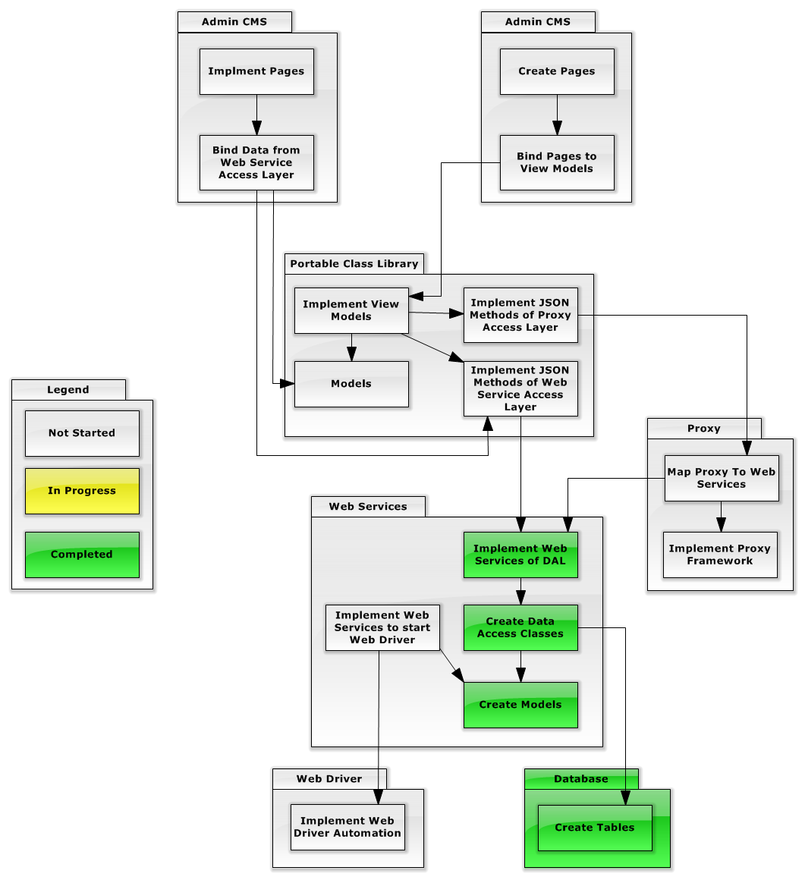

## 3.2 INT-02

|  |  |  |  |
| --- | --- | --- | --- |
| Integration ID | INT-02 | | |
| Test Name | Web Driver Test | | |
| Test Author | | Andy Bottom |
| Date Tested | | @TODO |

|  |  |
| --- | --- |
| Modules Involved | Web Services; Web Service Automation Layer; |

|  |
| --- |
| Test Summary |
| @TODO |

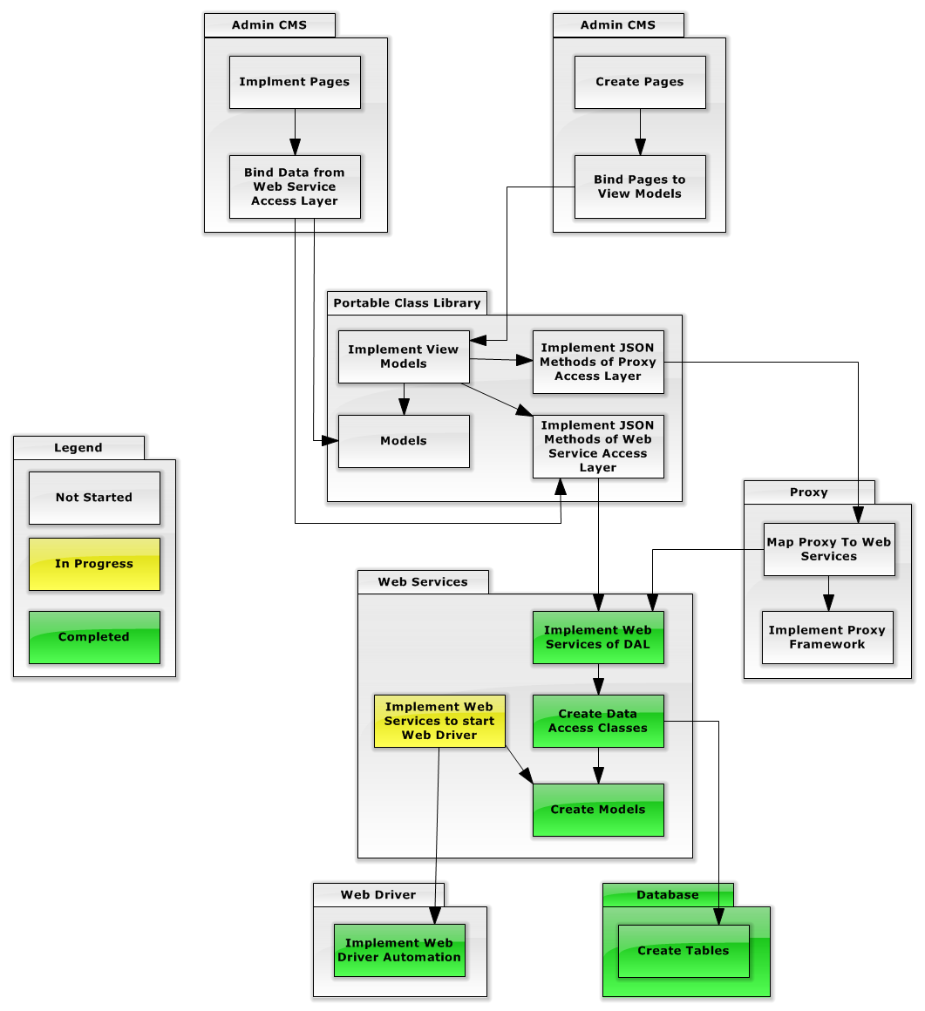

## 3.3 INT-03

|  |  |  |  |
| --- | --- | --- | --- |
| Integration ID | INT-03 | | |
| Test Name | Automation Test | | |
| Test Author | | Andy Bottom |
| Date Tested | | @TODO |

|  |  |
| --- | --- |
| Modules Involved | Web Service Automation Access Layer; PCL; |

|  |
| --- |
| Test Summary |
| @TODO |

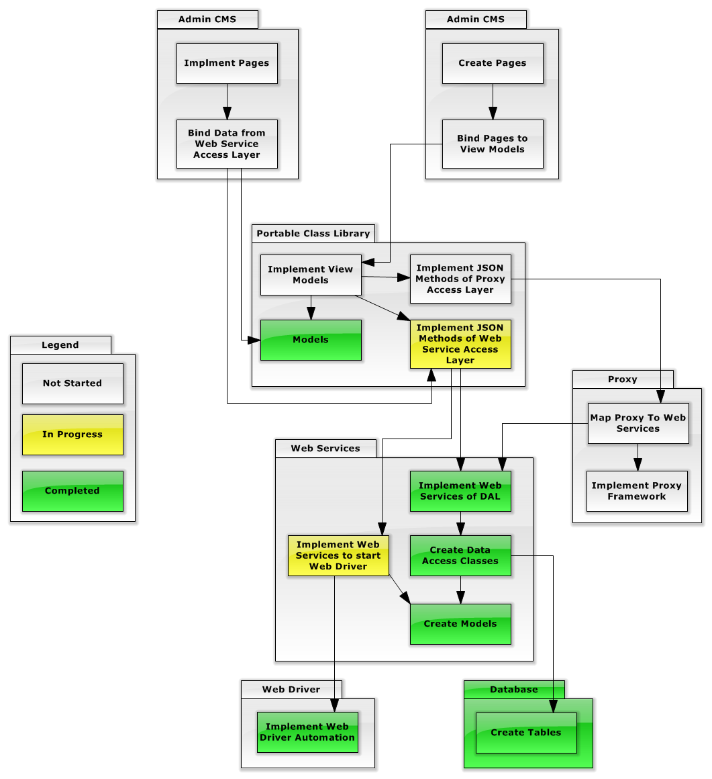

## 3.4 INT-04

|  |  |  |  |
| --- | --- | --- | --- |
| Integration ID | INT-04 | | |
| Test Name | CMS Binding Test | | |
| Test Author | | Andy Bottom |
| Date Tested | | @TODO |

|  |  |
| --- | --- |
| Modules Involved | Web Admin CMS; PCL |

|  |
| --- |
| Test Summary |
| @TODO |

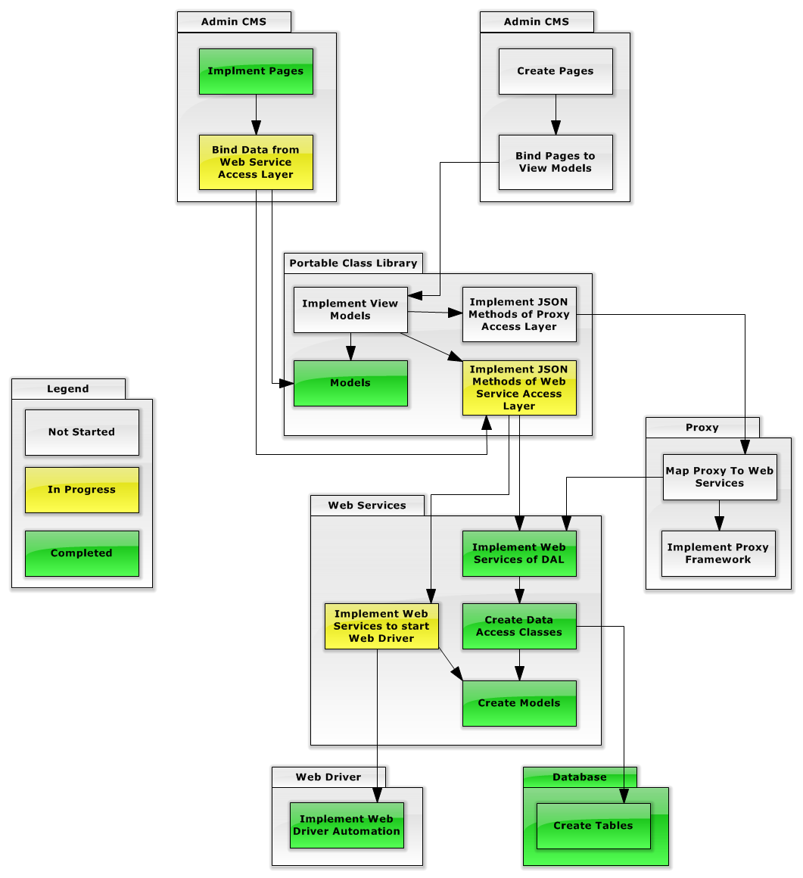

## 3.5 INT-05

|  |  |  |  |
| --- | --- | --- | --- |
| Integration ID | INT-05 | | |
| Test Name | Complete Web Service Test | | |
| Test Author | | Andy Bottom |
| Date Tested | | @TODO |

|  |  |
| --- | --- |
| Modules Involved | Admin CMS; PCL; Web Services; Web Driver; |

|  |
| --- |
| Test Summary |
| @TODO |

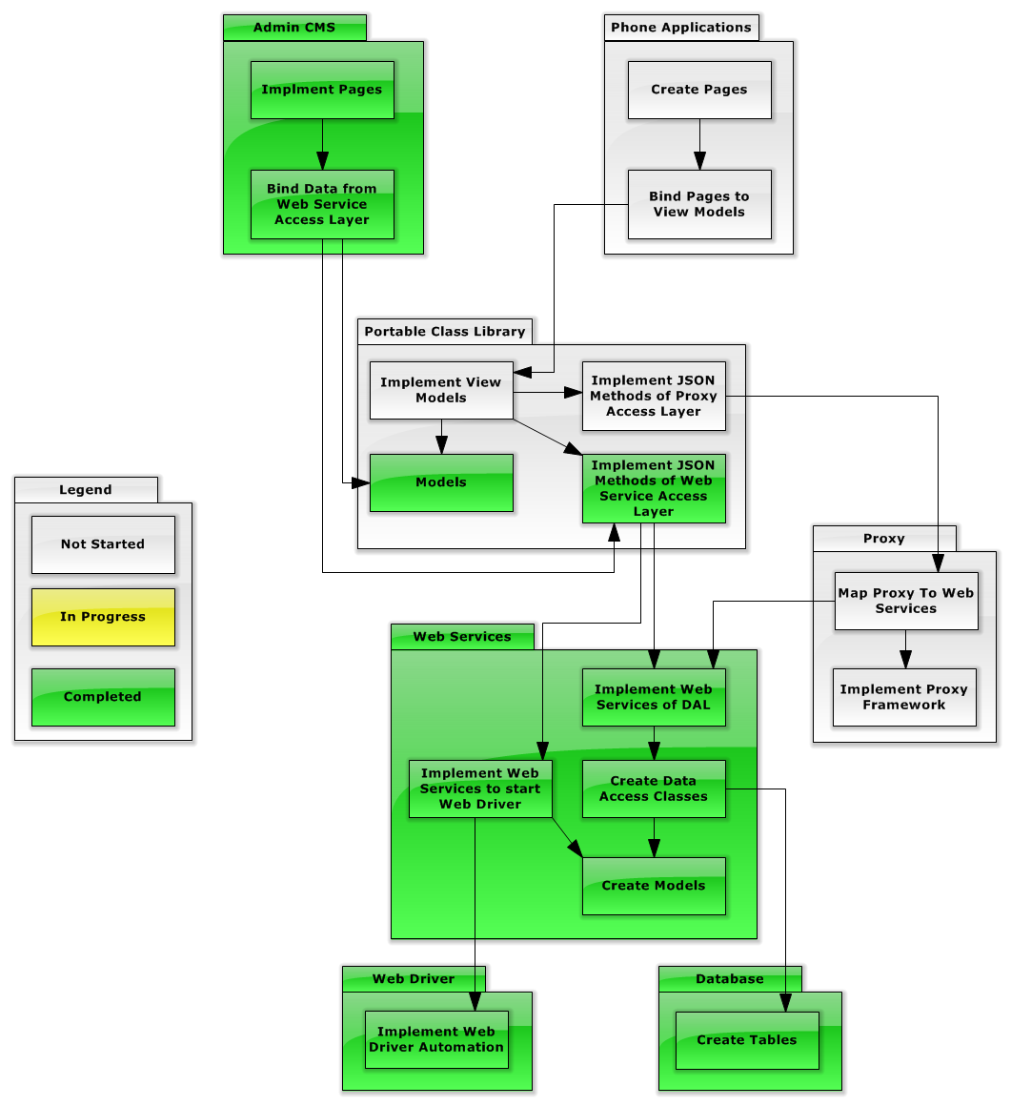

## 3.5 INT-06

|  |  |  |  |
| --- | --- | --- | --- |
| Integration ID | INT-06 | | |
| Test Name | Proxy Test | | |
| Test Author | | Andy Bottom |
| Date Tested | | @TODO |

|  |  |
| --- | --- |
| Modules Involved | Proxy; Web Services; |

|  |
| --- |
| Test Summary |
| @TODO |

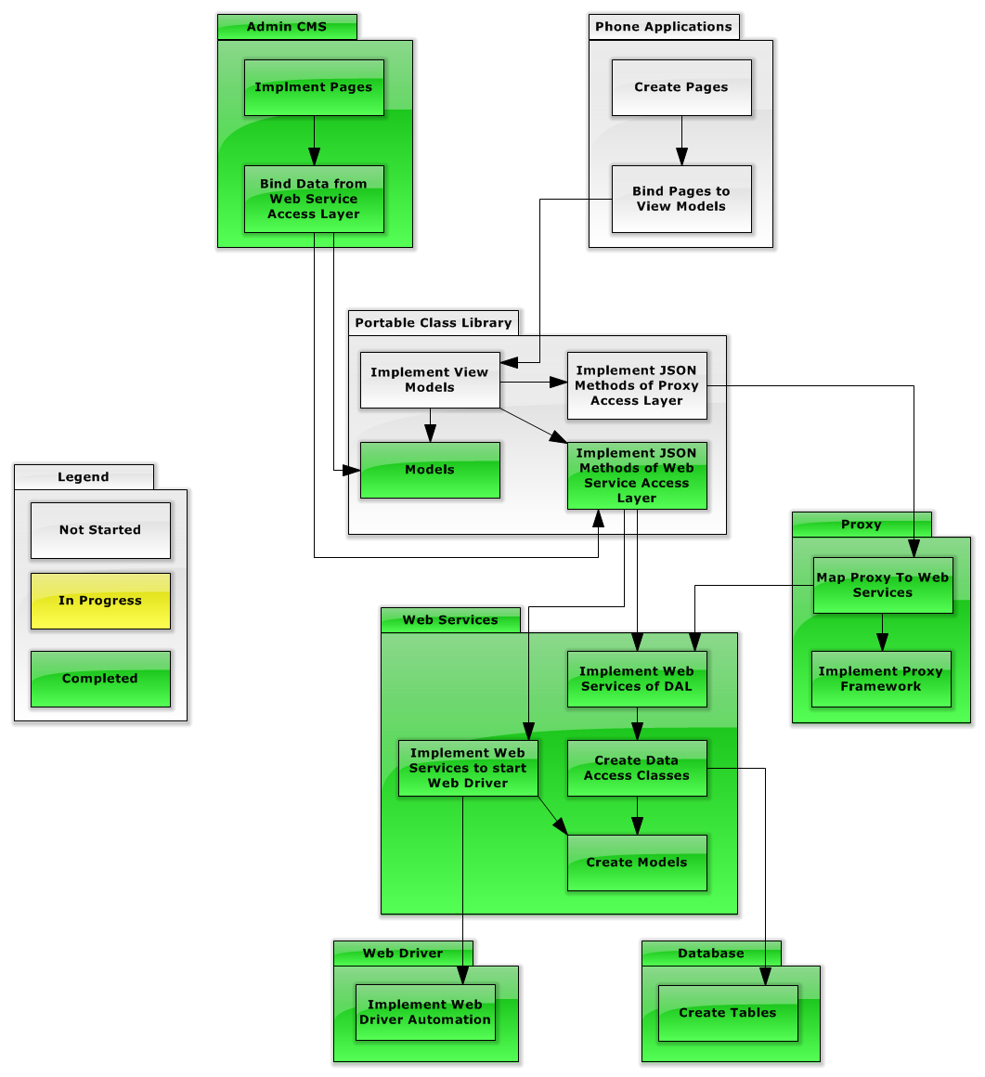

## 3.7 INT-07

|  |  |  |  |
| --- | --- | --- | --- |
| Integration ID | INT-07 | | |
| Test Name | Initial View-Model Test | | |
| Test Author | | Andy Bottom |
| Date Tested | | @TODO |

|  |  |
| --- | --- |
| Modules Involved | PCL; |

|  |
| --- |
| Test Summary |
| @TODO |

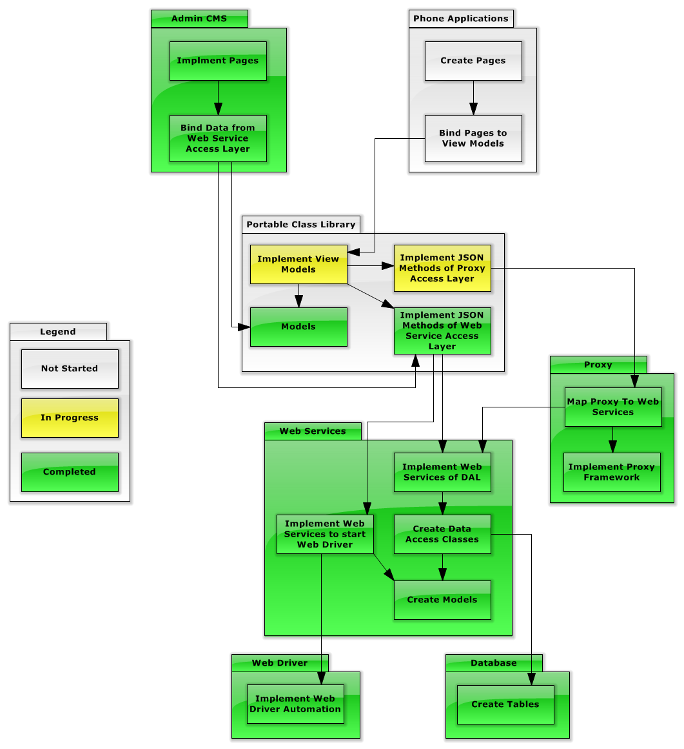

## 3.8 INT-08

|  |  |  |  |
| --- | --- | --- | --- |
| Integration ID | INT-08 | | |
| Test Name | Phone Binding Test | | |
| Test Author | | Andy Bottom |
| Date Tested | | @TODO |

|  |  |
| --- | --- |
| Modules Involved | Phone Apps; PCL; |

|  |
| --- |
| Test Summary |
| @TODO |

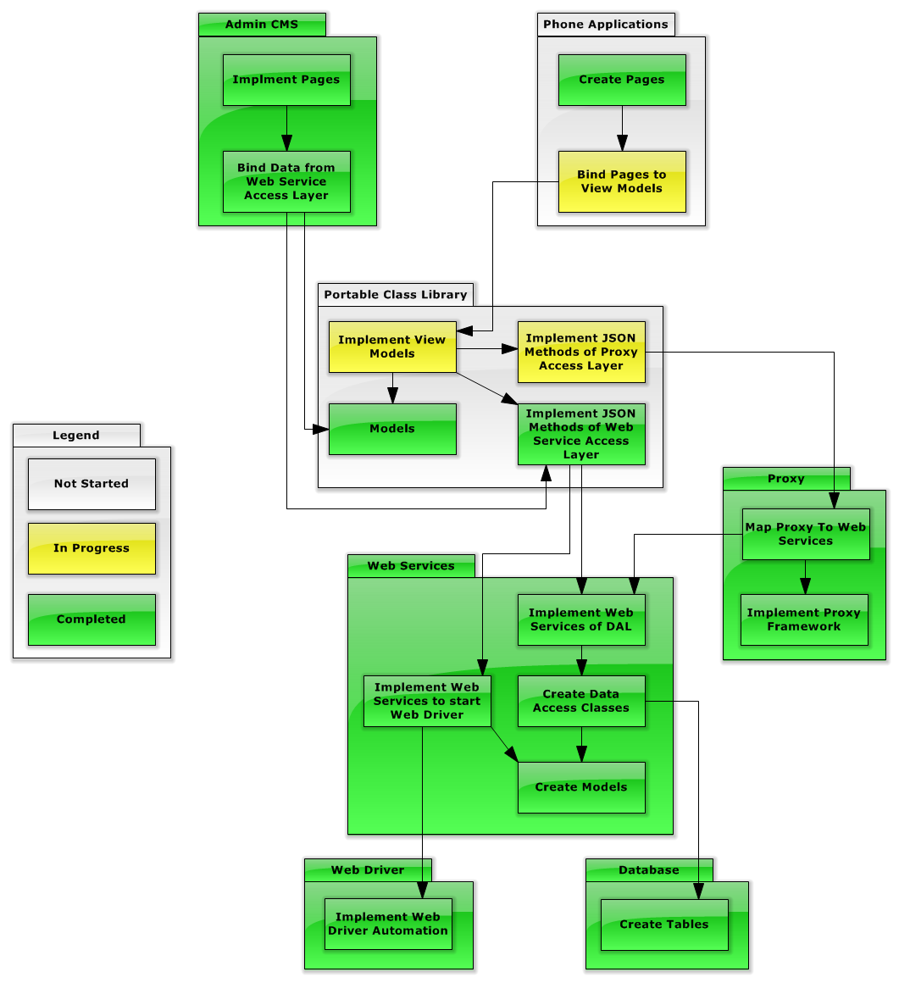

## 3.9 INT-09

|  |  |  |  |
| --- | --- | --- | --- |
| Integration ID | INT-09 | | |
| Test Name | Complete Integration | | |
| Test Author | | Andy Bottom |
| Date Tested | | @TODO |

|  |  |
| --- | --- |
| Modules Involved | Phone Application; PCL; Proxy; Web Services; |

|  |
| --- |
| Test Summary |
| @TODO |

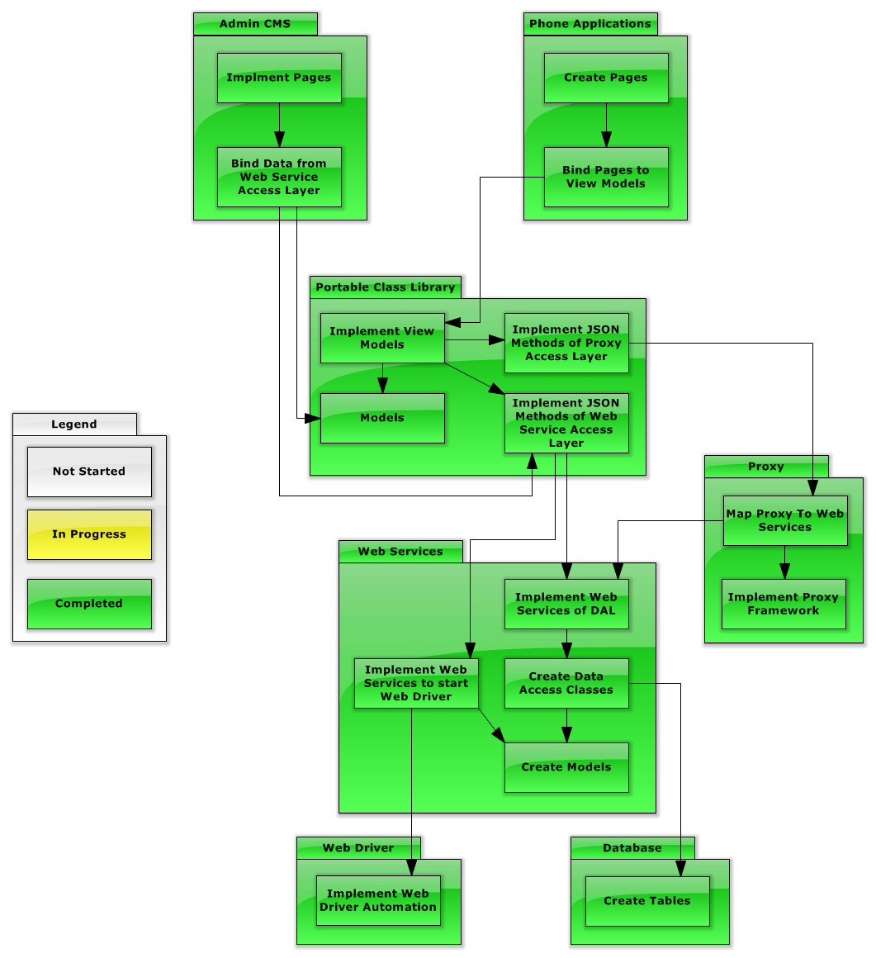

# 4 Conclusion

@TODO: Write a conclusion about the results